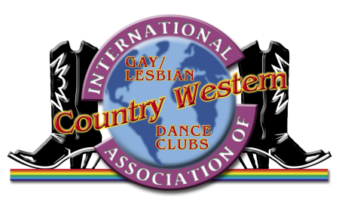

The Houston Hoedown

The 28th Annual IAGLCWDC Convention
May 25-28, 2023
Houston, Texas, USA

EXHIBITION APPLICATION FORM

1. House lights will remain up during performance.
2. Preferred length of routine: 3-7 minutes, max 8 minutes or contact Alan Gaudet or Charlie Monroe.
3. Must provide DJ with pre-mixed CD at rehearsal. Retrievable after performance.
4. All performers must be registered attendees of the host convention.

Team Name
(Couples please enter the names of both dancers here.)
IAGLCWDC Club Affiliation [none]

Contact Person Information

Name
E-mail Phone #
Address
City State/Province Zip/Postal Code Country

Performance Information

Number of Performers Number of Dances
Length of each dance (in minutes)
Total Length of Performance (8 minute maximum) (in minutes)
Description of routine(s) (line, medley, comedy, camp, sensual, c/w, non-c/w, drag, lip sync, etc.)
Props used (chairs, backdrops, puppets, etc.)
Will you require a costume change? (check one): yes no
If yes, length of performance time (in minutes): before change after change
Preferred performance night (check one): Friday Saturday No Preference
We will do our best to schedule all performances to meet this request, but we cannot guarantee it. Please be prepared to perform any night by 9 PM.
Form of audio (check one): CD (preferred) Other (specify)
Comments/Special Requests:

- Please complete this form, save it, and
  - return it as an e-mail attachment to: info@clubbolo.com (Canada) charlie@iaglcwdc.org (USA)
  - or, print and mail to: in Canada: in the USA:
Alan Gaudet Charlie Monroe
IAGLCWDC Convention Planning IAGLCWDC Convention Planning
Exhibitions Coordinator Assistant Exhibitions Coordinator
715 Desmarchais PO Box 182
Montreal, QC H4H 1S7, Canada Leflore, OK 74942-0182, USA
- Also, as soon as possible, please send bio and photo via e-mail to charlie@iaglcwdc.org to be posted on the hoedown website. Sending bio and photo constitutes permission to publish such on the hoedown website, http://outhoedown.com.

